**Water ePermitting System**

**Concentrated Animal Feeding Operations (CAFO) WPDES Permit Applications**

Below are the steps to complete and submit CAFO WPDES permit applications, engineering documents, and post application updates using the ePermitting system. More details, including screen shots, are included starting on page 2.

|  |  |
| --- | --- |
| **Need Assistance?** | **Please use the** [**ASK FOR HELP**](https://permits.dnr.wi.gov/water/SitePages/Issue%20Submittal.aspx) **link for user support & someone will contact you.** |
| **Website Information** | * Go to the [Water Portal web Page](http://www.dnr.wi.gov/permits/water), either type in “Water Permits” in the search bar on the DNR home page * or go directly to [dnr.wi.gov/permits/water](http://www.dnr.wi.gov/permits/water) |
| **WAMS ID & Logging in to the ePermitting System** | * Need a WAMS ID: Choose **Register** for a WAMS ID and return to the Water Portal webpage, choose **Begin** to log into the ePermitting system. * Already have a WAMS ID: Choose **Begin** and login with your WAMS ID and password * You will be redirected to the “My Permit Applications” webpage. Here you can either start a new application or edit an existing one.   + Start new application: choose **Livestock Operations** from the list of Permit Categories in the left menu.   + Editing an existing application: choose the project name listed under Draft Permit Applications or Signature Confirmation Needed. |
| **Permit Application General Information** | * Enter a Project Name of your choice. * Select a Permit Action and Activity from the drop-down menus. * Select the appropriate county from the Facility County drop-down. * *Use the drop-down that appears for the Facility Name and select your facility, this will generate the Facility Number (drop-down does not appear for preliminary applications). * Select **Next** to complete the application forms and add attachments.   **\*Note:** only facilities that submitted a preliminary application or have been previously permitted will appear in the Facility Name drop-down. |
| **Permit Application Forms & Attachments** | * Using the **Edit Form**, **Next, Upload Plan/Documents** and **Attachments** buttons, navigate through the application process. The **Home** button will bring you back to the General Information Page. * Use the **Press to Refresh Missing Items Below** buttonat the bottom of each page to identify missing requirements. * Once the required forms and attachments are completed, the **Sign and Submit** button will become active. |
| **Sign and Submit the Application** | * *Choose the **Sign and Submit** button, then enter the name of the person signing (if applicable). * Read the **Terms and Conditions** and select the check box next to the signature area. This will fill in a digital signature using your WAMS ID information. * Choose the **Sign and Submit to DNR** button to proceed to the final signature step * You receive an email to your WAMS email address. * Follow the instructions on this email to complete the signature process.   \***Note:** Preliminary, final, and reissuance applications must be signed by an authorized representative. If necessary, use the “Assign Role” feature to send applications to another WAMS ID user for editing and signing (instructions below). |
| **After Submitting the Application** | A confirmation email goes to the email address provided in the WAMS ID, acknowledging the application has successfully been submitted to the DNR for review.  After DNR Intake reviews your application, you may track the status of permit applications at: <https://permits.dnr.wi.gov/water/SitePages/Permit%20Search.aspx> |

**Steps with Descriptions and Screen Image Examples**

1. Below are links to the Water Portal Page, program webpages and how to start the ePermits for the Water programs.
   1. To get to the Water Permit Water Portal Page either:
      * Go to [dnr.wi.gov](http://www.dnr.wi.gov/) and type in “Water Permit” into the search bar
      * Go to [dnr.wi.gov/permits/water/](http://www.dnr.wi.gov/permits/water/)

At this page you can: **REGISTER** for a WAMS ID, **BEGIN** a new or edit an existing application, **VIEW** public notices of the DNR’s intention to authorize activity relating to water, including permits issued to the DNR, **TRACK** the status of Wisconsin’s water permits, and **WATCH** instructional training videos.

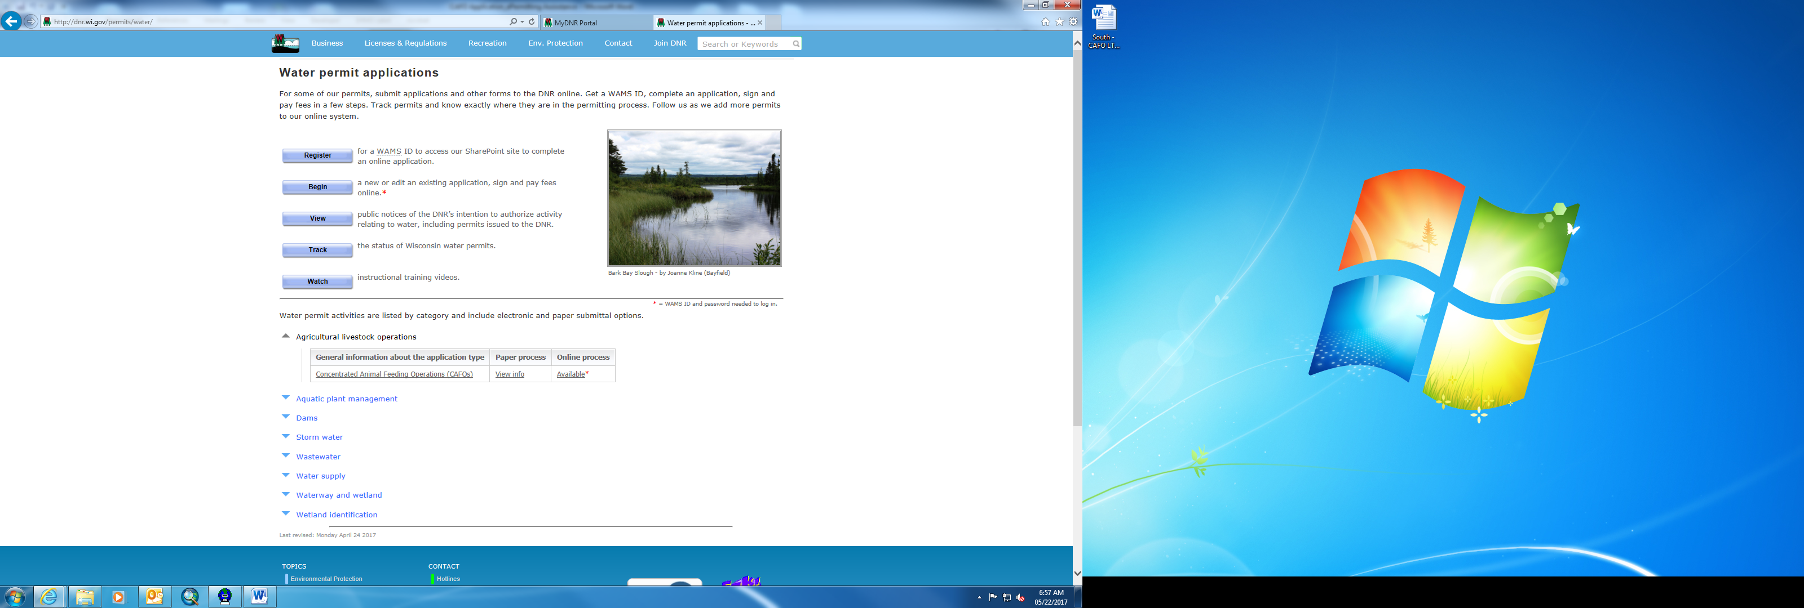

Towards the bottom of the webpage there are tabs with links for the different permitting programs that can be used to navigate to the program webpages to learn more about the requirements for the various permit programs.

1. A WAMS ID is required for applying for permits using the Water ePermitting System, but it is not required to view Public Notices, or Track the status of water permits. The WAMS ID is a secure login for all State of Wisconsin programs. Choose **REGISTER** to get a WAMS ID. Then navigate back to the [Water Portal Page](http://dnr.wi.gov/permits/water/) to start a new permit application or work on an existing one.
2. Choose **BEGIN** to log into the ePermitting system so that you can either start a new permit application or resume editing an existing one.
3. Login using your WAMS ID by clicking the **Public Access (WAMS ID Required) – Apply for WDNR Water Permit Applications** and filling in your WAMS ID and password.

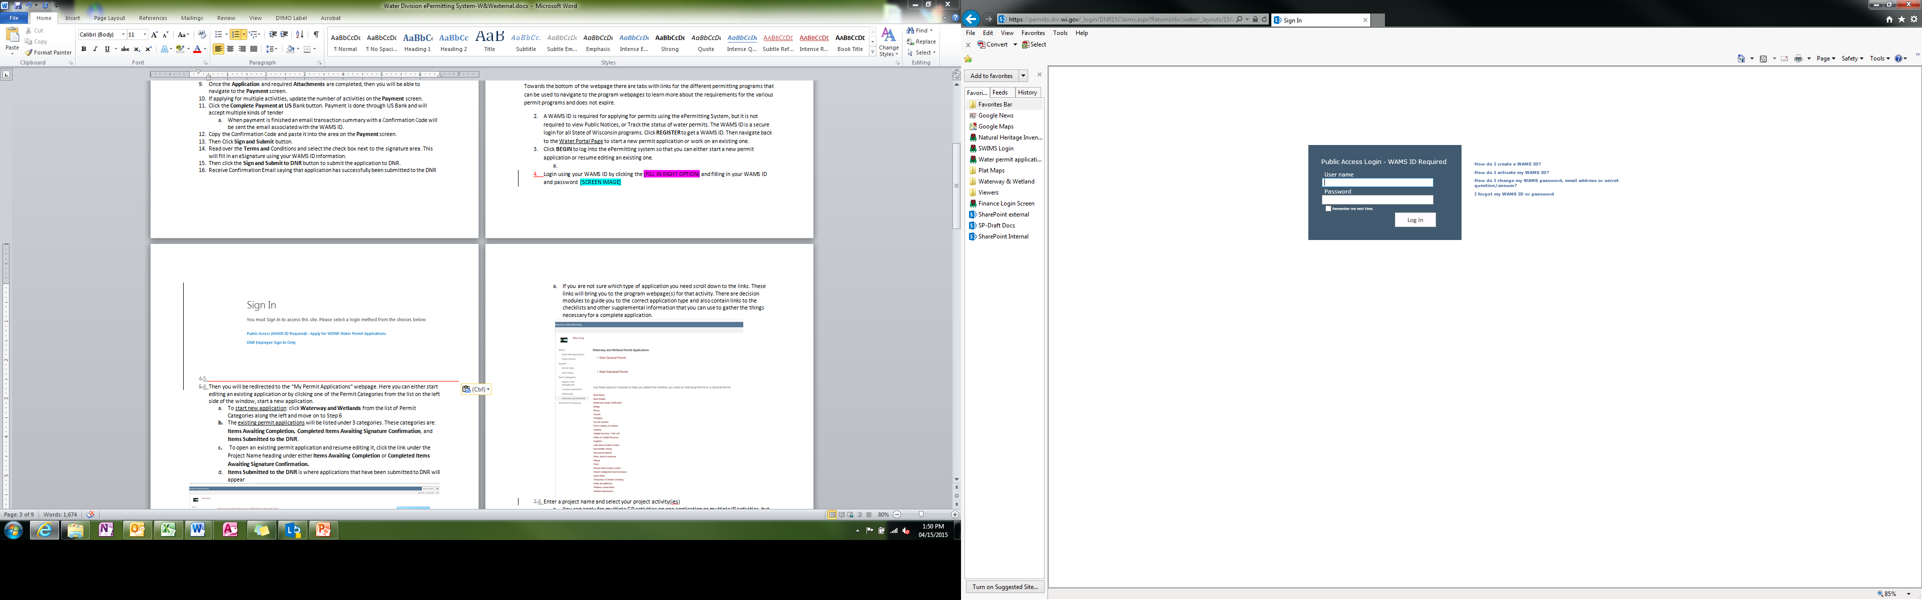

1. Then you will be redirected to the **My Permit Applications** webpage. Here you can either start a new application or continue editing an existing application.
   1. To start new application: choose **Livestock Operations** from the list of Permit Categories on the left-hand side of the screen and proceed to Step 6.
   2. To edit an existing application: locate your application below one of the two categories, **Draft Permit Applications** or **Signature Confirmation Needed**, and click the link under the Project Name heading to open your application**.**
   3. Applications that have been successfully submitted to the DNR can no longer be accessed for further editing.

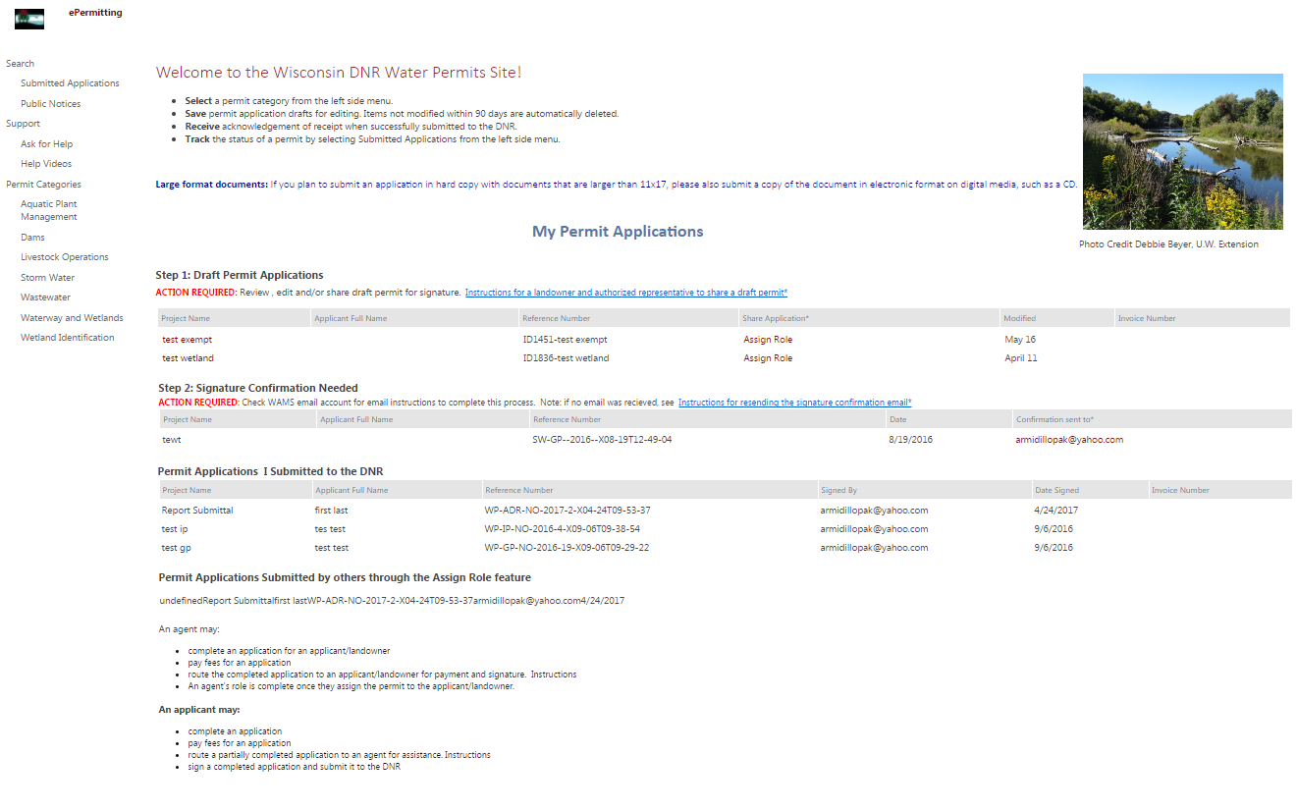

1. Complete the required fields on the Permit Application General Information page.
   1. Enter a project name. This name will be displayed on the welcome page from the previous step.
   2. Choose the appropriate **Permit Action** and corresponding *Activity:*

* Select **Permit Application** to submit CAFO WPDES *Preliminary, Final, or Reissuance* applications.
* Select **\*Engineering Plans and Specifications or Reports** to submit individual *Plans and Specifications, Evaluations, and Post Construction* reports.
* Select **Post Application Reports and Updates** to submit *Nutrient Management Plan Substantial Revisions, Annual Reports, and Nutrient Management Plan Annual Updates*.

**\*Note:** Evaluations required as part of a complete *final* or *reissuance* permit application (determined by your regional specialist) must be included as part of a **Permit Application** submittal. Plans and specs required for permit applications must be submitted as a separate engineering submittal prior to (or at the time of) your permit application submittal.

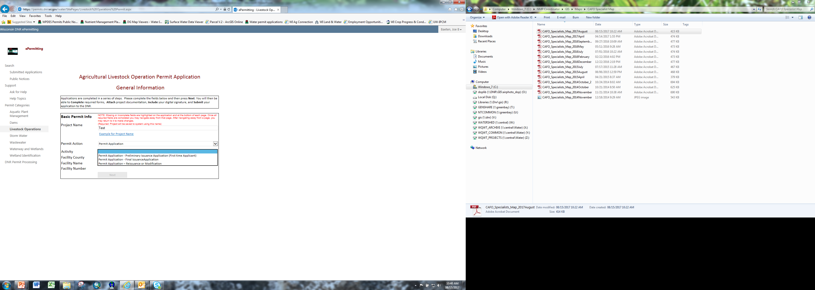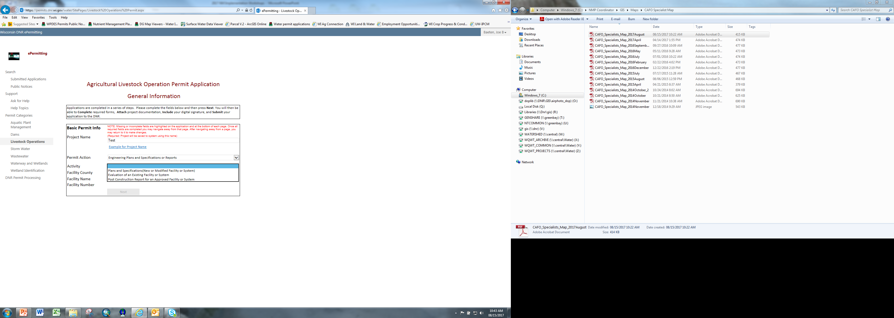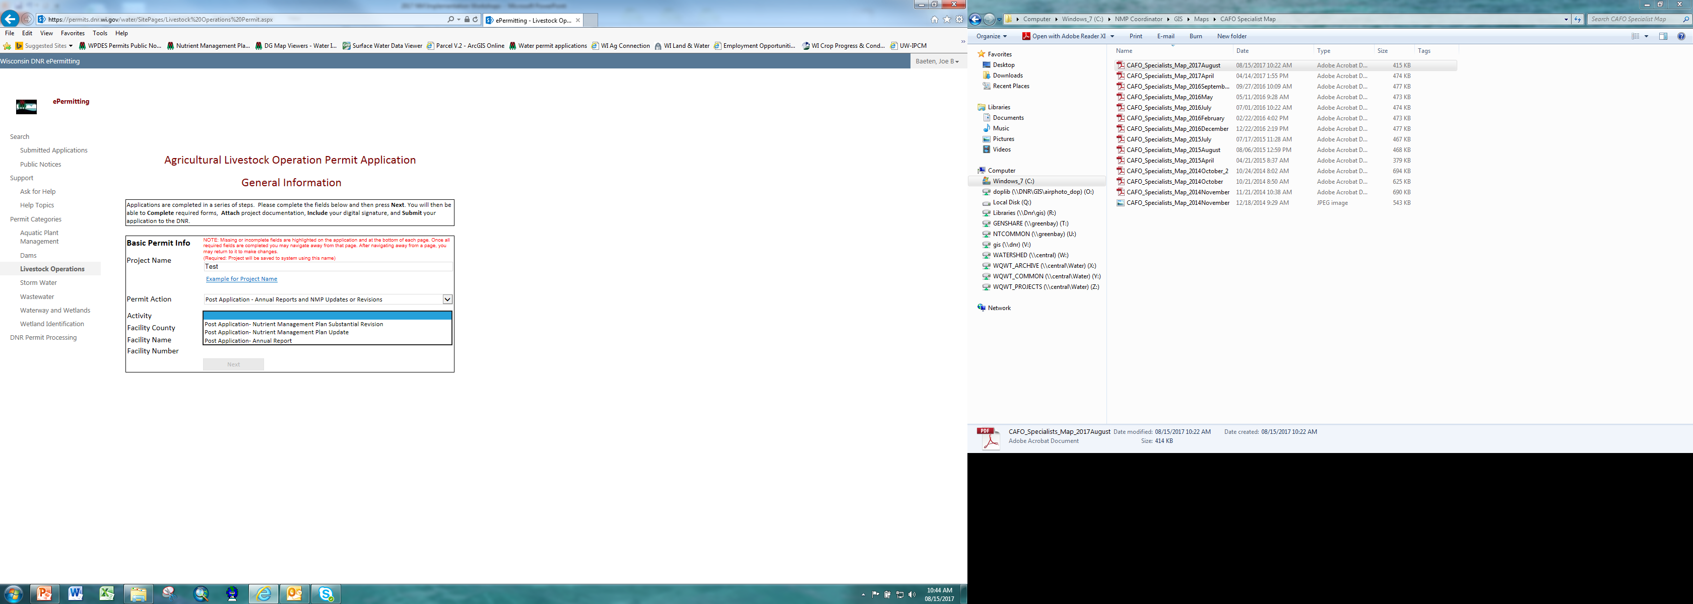

* 1. Select the appropriate county from the Facility County drop-down.
  2. **\***Use the drop-down that appears for the Facility Name and select your facility. This will automatically generate the appropriate Facility Number (drop-down does not appear for preliminary applications).
  3. Click the **Next** button to complete the related forms and upload attachments.

**\*Note:** Only facilities that submitted a preliminary application or have been previously permitted will appear under the Facility Name drop-down. If you are a new CAFO applying for a first time issuance, please submit a preliminary application before submitting other CAFO applications.

1. Using the **Edit Form**, **Upload Plan/Documents, Next,** and **Attachment** buttons, navigate through the application process. Selecting the **Home** button will bring you back to the General Information page from step 6.
   1. Use the \***Edit Form** button to complete the required form(s). While editing a form, use the **Next** button to access the next page(s). Use the **Attachments** button to return to the Forms and Attachments page.

Content on this page will vary depending on **Permit Action** and *Activity* selected in step 6. Forms and Attachments Page for final/reissuance permit application is shown below.

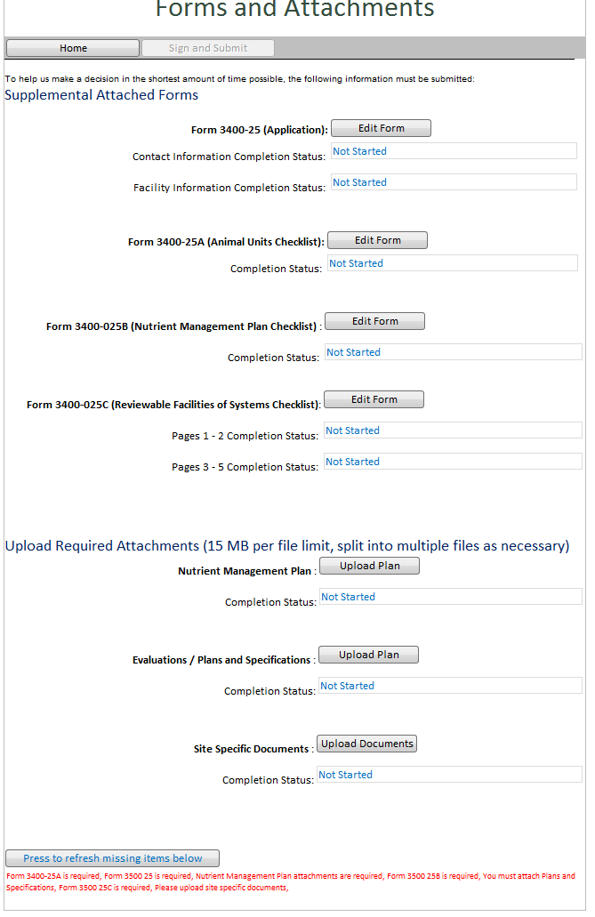

Evaluations:

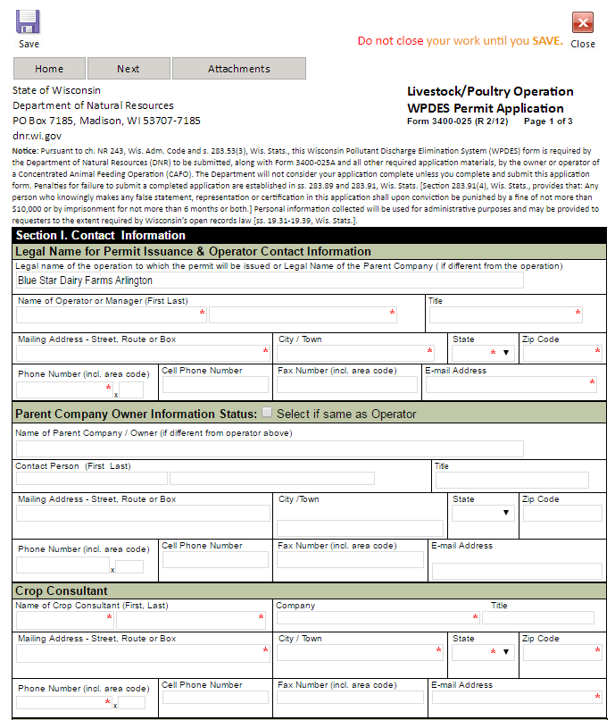

**\*Note:** If application form **3400-025** and/or **3400-025A** are required, you will need to provide information for each site managed by your operation (if applicable).

* Section II of the **3400-025** form is required for each site and must list specific structures/systems (both existing and proposed) for each of the applicable categories. Additional sites and items in this section can be added using the corresponding blue drop-downs provided on the form.

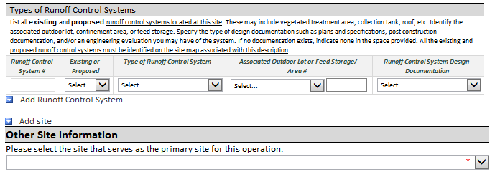

* After all site locations have been added to Section II of the **3400-025** form, use the drop-down to select which location is the primary site for your operation.
* Form **3400-025A** animal unit worksheet(s) is also required for each site. A **current animal unit** worksheet must be completed for each site added during the previous step. A **projected animal unit** worksheet must also be completed for each site, unless the option for “no projected increases” is selected.

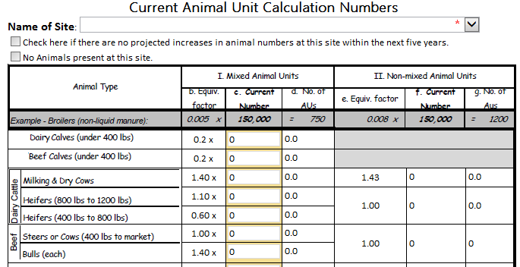

* Use the “Name of Site” drop-down to select the corresponding site for each animal unit worksheet (options for site names are based on the sites added to section II of the 3400-025 form)
* Enter the appropriate amount for each animal type. The animal unit totals at the bottom of the form will be calculated automatically.

1. Use the **Upload Plan/Documents** button to see the attachments required for a specific portion of the application and select *Click here to attach a file* to upload documents. Use the **Forms and Attachments** button to return to the Forms and Attachments page.

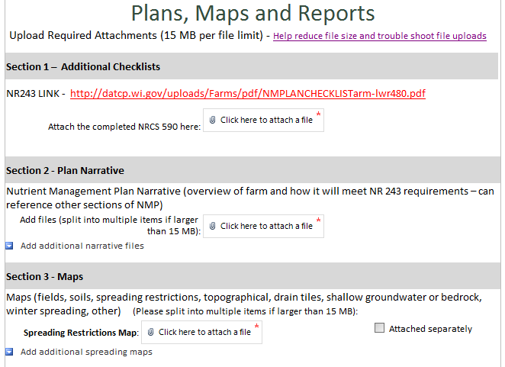

* 1. If help is available for an attachment, it will be listed next to the attachment button. This link will display and hide the help text as it is selected.

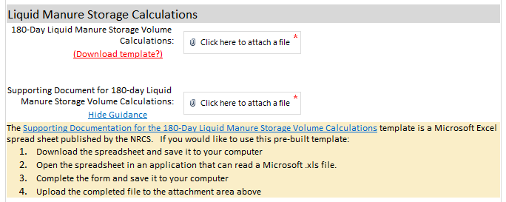

1. Use the **Press to refresh missing items below button**, locatedat the bottom of each page, to identify if any required fields are missing. **\***Required fields are indicated with a **red** asterisk.

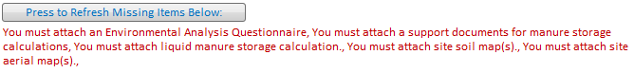

**\*Note:** Completing all the requirements identified by this feature will not guarantee a complete application. Each submittal will be reviewed by the Department and additional information may be requested.

1. Once all requirements are complete, the **Sign and Submit** button at the top of the Forms and Attachments page will become active.

1. Choose the **Sign and Submit** button.
2. Read over the **Terms and Conditions** and select the check box next to the signature area. This will fill in an eSignature using your WAMS ID information.

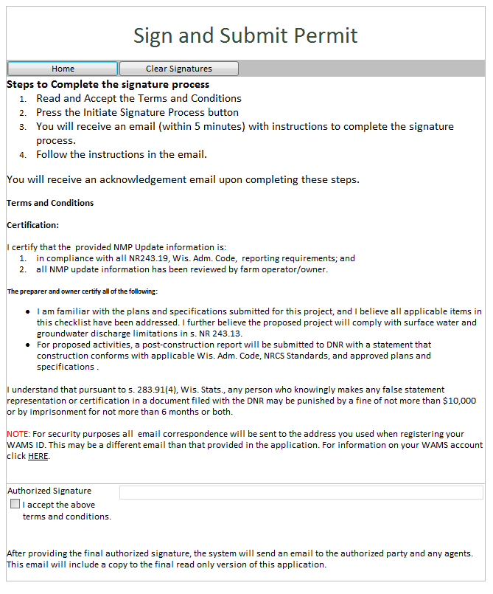

**\*Note:** Preliminary, final, and reissuance applications must be signed by the operation’s authorized representative (WAMS ID is required for e-signature). Consultants completing applications on the operation’s behalf can use the “Assign Role” feature to send applications to the operation to sign. See instructions at the end of the user guide.

1. Choose the **Sign** button to receive confirmation you have completed step 1 of the signature process.

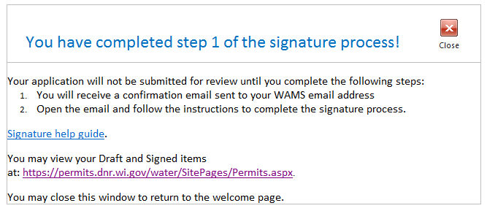

1. Receive an email with a onetime password needed to finish submitting the application to DNR (sent to email associated with your WAMS ID).
   1. Here you will be able to print or save a copy of the finished application if desired.

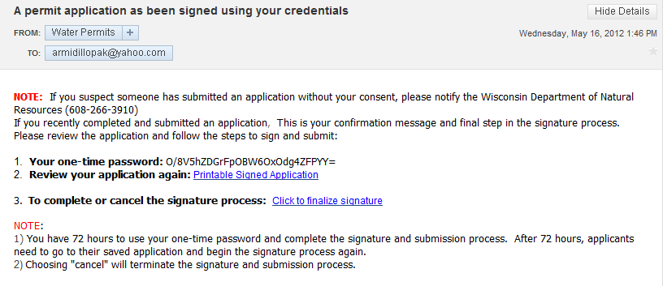

1. Copy the onetime password that is located in the email and choose **Click to finalize signature** link in the email.
2. This will bring you back to your application where you will need to enter your one-time confirmation code.

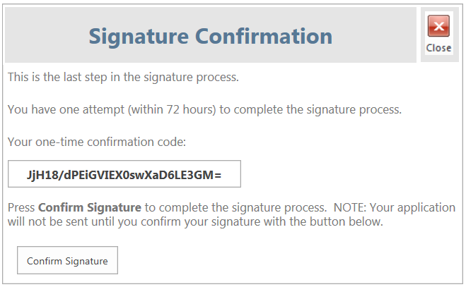

1. Paste the onetime password and select **Confirm Signature** to finish the signature process and submit the application to the DNR for processing.
   1. This second signature process is related to the Wisconsin Pollutant Discharge Elimination System (WPDES) permit applications.
2. After completing the signature process, you will be rerouted to the **My Permit Applications** page so that you can start a new permit application, resume editing an existing application, or complete the signature process for another application.

**Hints, Tips and Tricks**

Using the **Assign Role** feature, you also have the ability to start a permit application and then share it with someone else for editing. This feature is commonly used by consultants to start a permit application, complete the form(s) and attachments they are responsible for (e.g. engineering evaluations), send the application to another party responsible for a separate portion (e.g. nutrient management plans), and then finally send to an authorized representative to sign. Please note that if you use this feature, the permit application may not appear under the appropriate category area as described above.

This feature is necessary for permit applications that require the authorized representative’s signature. The **Assign Role** feature is located on the “My Permit Applications” webpage discussed in step 5 above. All consultants and authorized representatives need to have a WAMS ID set up prior to using this feature. You need to know the email associated with the receiving person’s WAMS ID to send the application to them. Please refer to the link titled **Steps for a landowner and agent to share a draft permit** for in depth description of how to do this.

If you are having issues please refer to the [**ASK FOR HELP**](https://permits.dnr.wi.gov/water/SitePages/Permit%20Search.aspx)link along the left hand side. Someone will be in contact with you to help with your issue or answer your question.

[**VIEW**](http://dnr.wi.gov/permits/water/notices.html) public notices of the DNR’s intention to authorize activity relating to water, including permits issued to the DNR, [**TRACK**](https://permits.dnr.wi.gov/water/SitePages/Permit%20Search.aspx) the status of Wisconsin’s water permits, and [**WATCH**](http://dnr.wi.gov/permits/water/getStarted.html) instructional training videos.

